# **Blue Papers Recommendations**

*June 26th 2019*

The Blue Papers form the scientific basis for the High-Level Panel and as such have the opportunity to directly influence political leaders to shape a more sustainable and equitable ocean economy. In addition to identifying and quantifying the challenges (i.e. costs of inaction); sharing successful case studies; and analysing the current incentives that drive the status quo and the alternative incentives that could be put in place to drive different outcomes; we are looking to the Blue Papers teams to identify and recommend implementable solutions in line with their conclusions, that are as specific as possible and targeted to specific entities.

This document indicates the possible elements for consideration within Blue Paper recommendations, that can help to enable their uptake. Teams are asked to consider the elements described below and to include these as far as is possible. It is recognised that not all of these elements will be applicable for a given recommendation.

## **1. Elements of an ideal recommendation**

The following aspects are suggested as elements of an ideal recommendation:

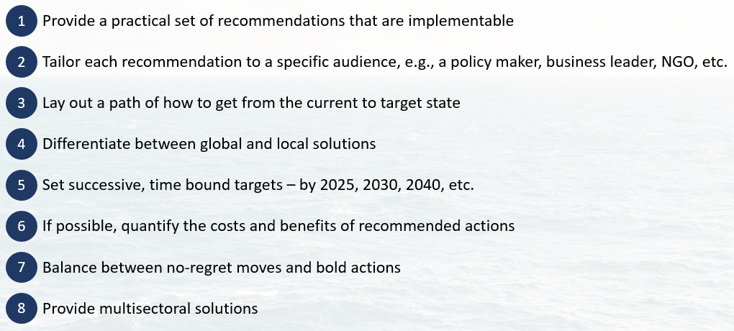

## **2. Typical format for recommendations**

## “Why is it not happening, and what needs to be done, by whom, and when to make it happen”

Ideally, BP recommendations would be phrased in the spirit of “Why is it not happening, and what needs to be done, by whom, and when to make it happen”. Blue Paper authors are encouraged to imagine that they have been asked to present the findings from their papers to a senior Minister or CEO and to orient their recommendations in this spirit.

The following structure and format is offered as a guide to maximise the dissemination and uptake of recommendations by core audiences. This is not intended to be prescriptive; each Blue Paper is different and may require a different approach:

* **Short statement/ reminder of the challenge(s) addressed** 
  + Should refer to the previous sections of the BP
  + We expect several challenges identified in each BP, but the number is left to the authors’ consideration
* **Recommended priority pathway or solutions, comprising the following “ingredients” where possible** (wording to be adjusted by BP lead authors, but content should cover the items illustrated below):
  + *We recommend [actors: policy makers, incumbents, NGOs, etc.] to [deliver/ invest in/ protect/ commit to/ eliminate] a [quantified target: dollars, GW, tonnes, vessels, % of EEZ, % of GDP, etc., or international standard/agreement/cooperation/governance of xx] by [date/ year].*
  + *By doing so, this will address [wrong incentive removed, or new positive incentive created, or need for international framework] and help tipping the system towards the desired outcome.*
  + *Associated benefits / costs with this solution is estimated to be [XX per annum per country, per hectare, per tonne of fish, per GW, etc.], with a positive ROI expected after [X years] [in economic terms where relevant, or can be a “ROI” in terms of protected biodiversity or CO2 avoided or absorbed, just to name a few examples]*
  + *Alternative possible actions include [XX] accounting for political and institutional constraints but will only achieve [X%] of the target.*

***

Creating these targeted, tangible and impactful recommendations is a complicated task, but will be key to creating the ambitious impact the HLP desires. To support the Blue Paper teams in shaping their recommendations, the WRI Secretariat is available to schedule 1:1 guidance/brainstorming sessions with the Expert Group Co-Chairs and Lead Writing Team before the due date of the first draft (as agreed) for interested teams.